**PROJECT DEVELOPMENT PHASE**

**SPRINT – 3**

|  |  |
| --- | --- |
| Team ID | PNT2022TMID35428 |
| Project Name | Industry - Specific Fire Management System |
| Date | 12 November 2022 |

Sending the data from IBM Watson to Node Red:

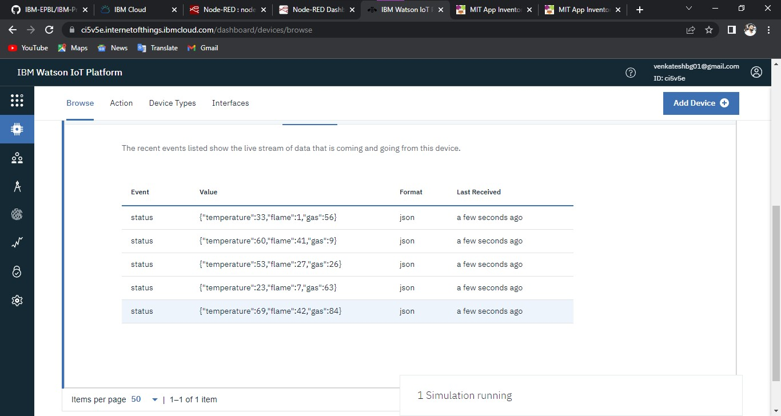

Node Red Connection:

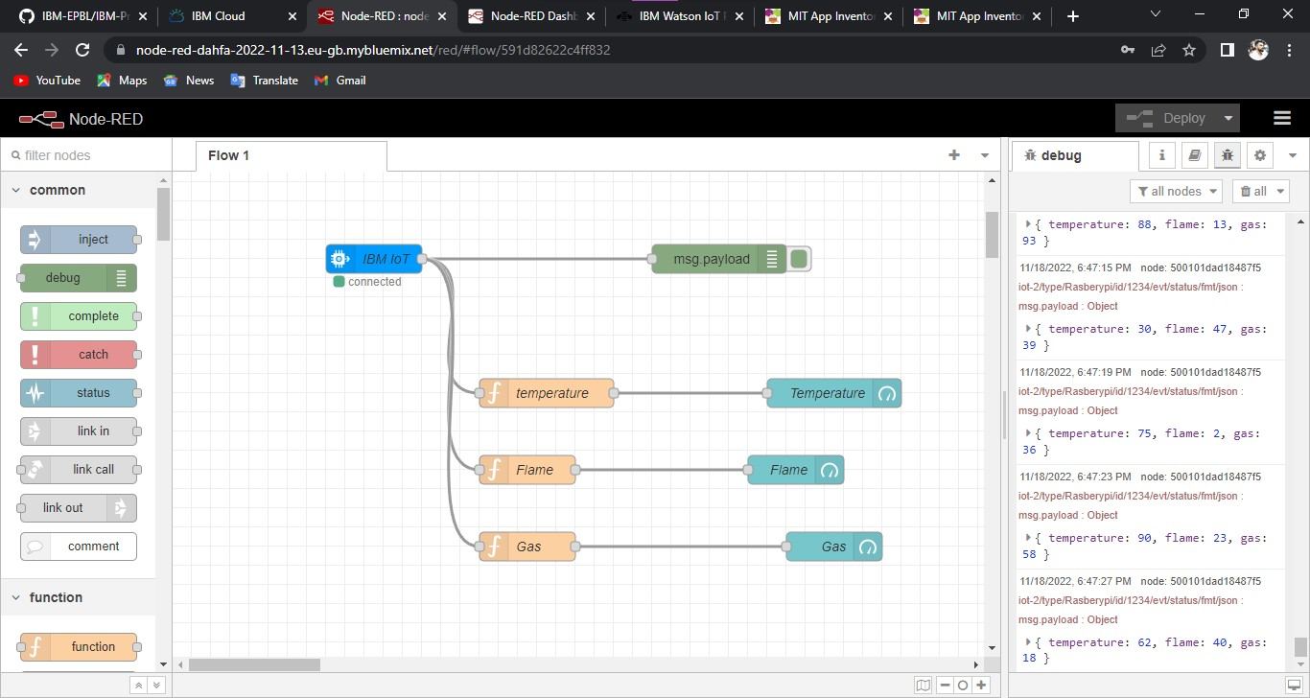

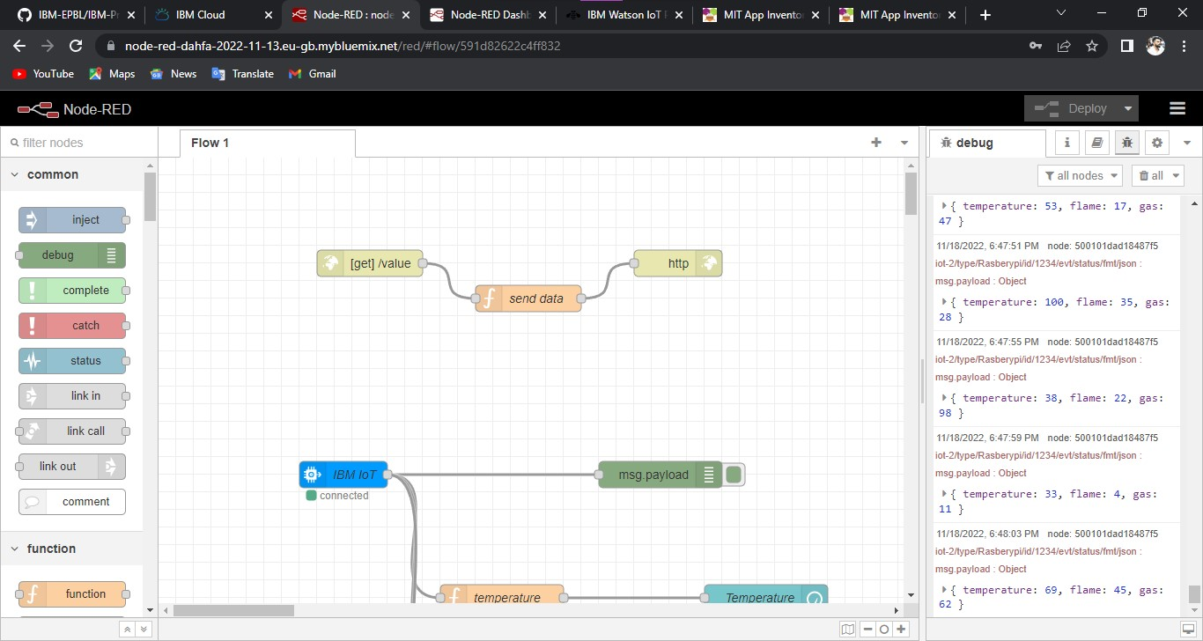

Web UI:

